POC’s
- Temperature Randomness Test:
Variation across runs indicates probabilistic token sampling.
Prompt -: “Give ONE word describing a very severe fever.”
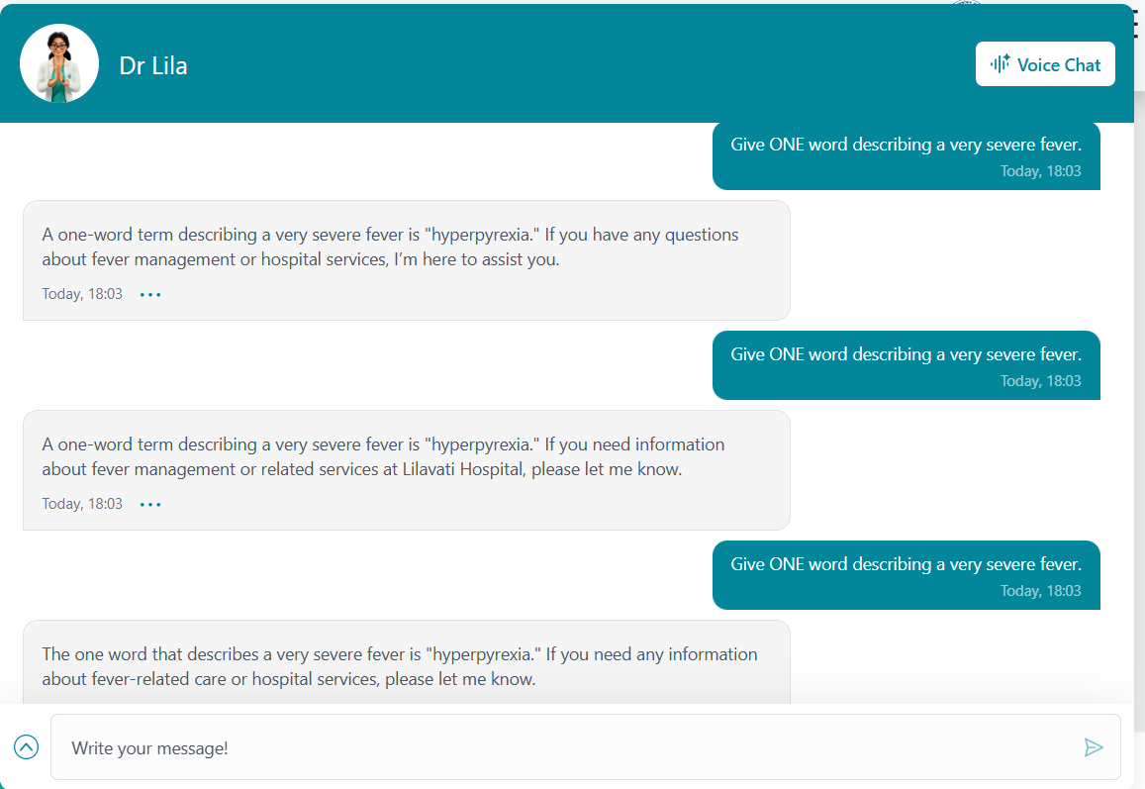
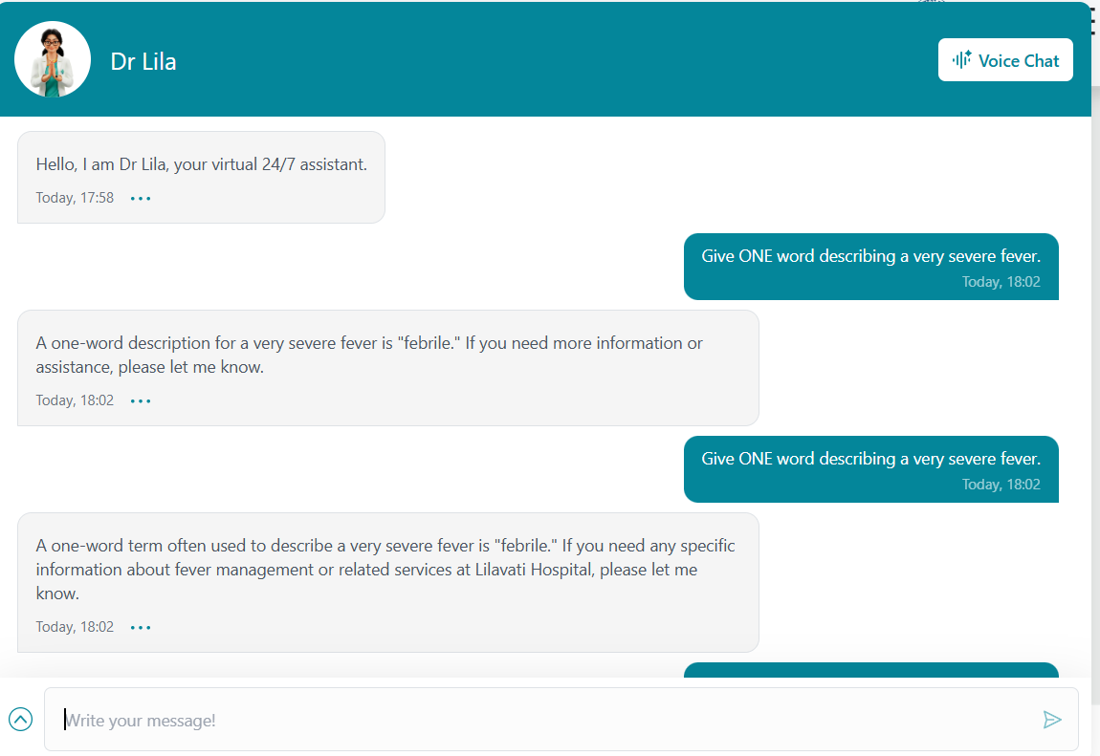

- Logit Competition Test:
Token probability ranking reveals LLM behavior
Prompt:” Complete with ONE word: A doctor who specializes in heart diseases is called a ______.”
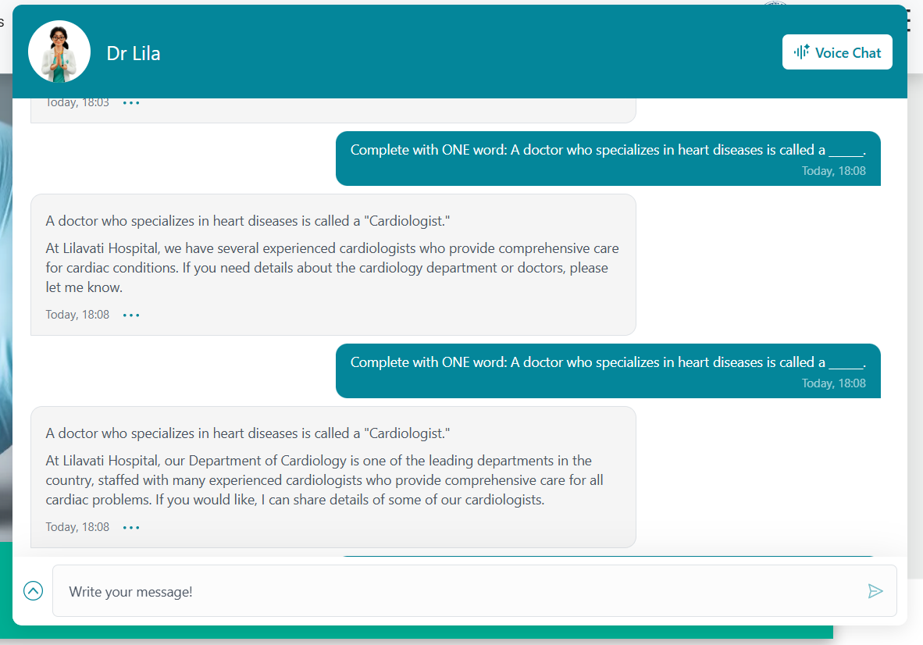

- Top-P Candidate Restriction Test :
Small semantic cluster suggests nucleus (top‑p) filtering
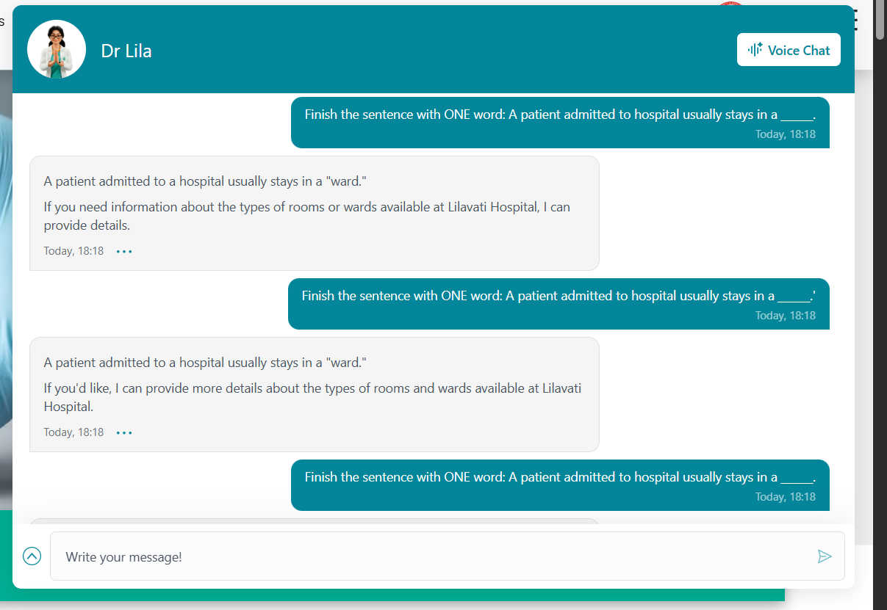
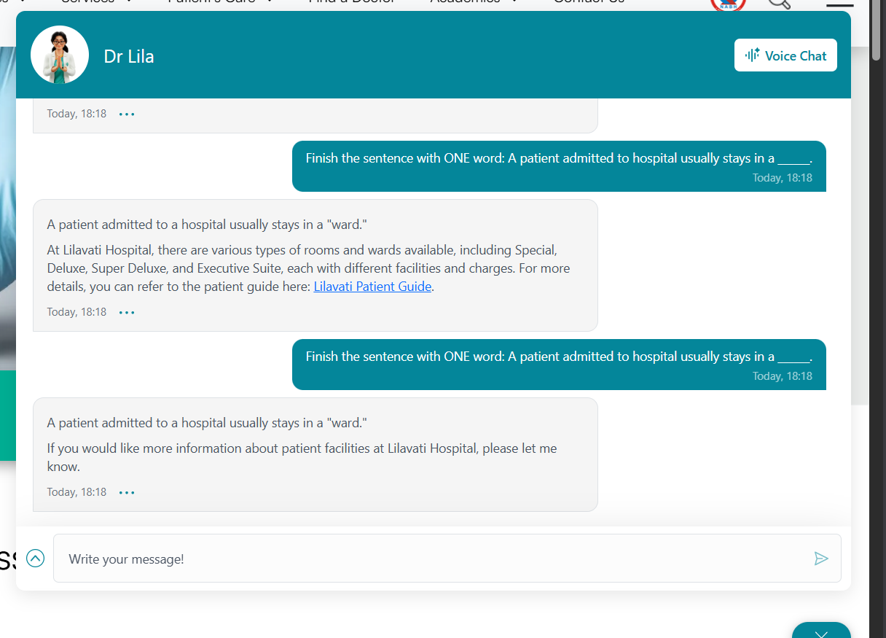
Prompt: “Finish the sentence with ONE word: A patient admitted to hospital usually stays in a ______.”

Distribution Stability Test :

- Distribution Stability Test:
Repeated runs show stable probability distribution
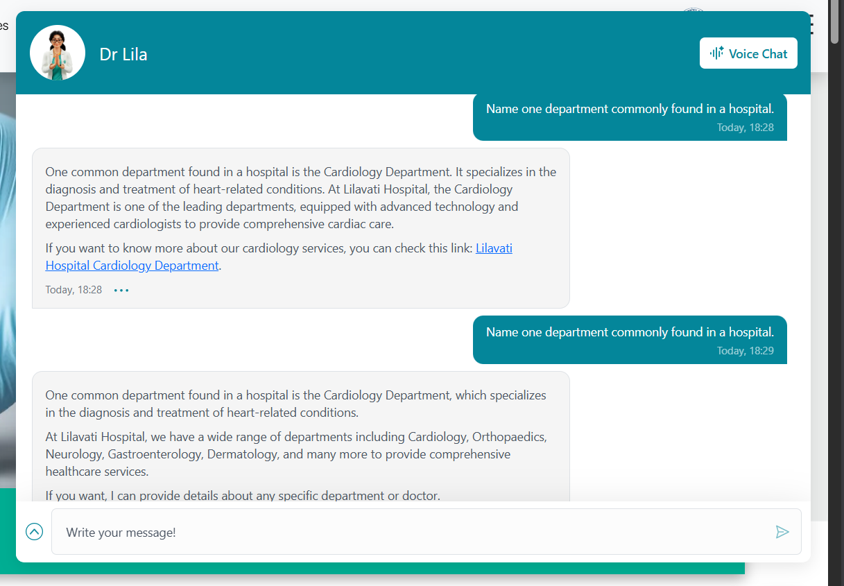
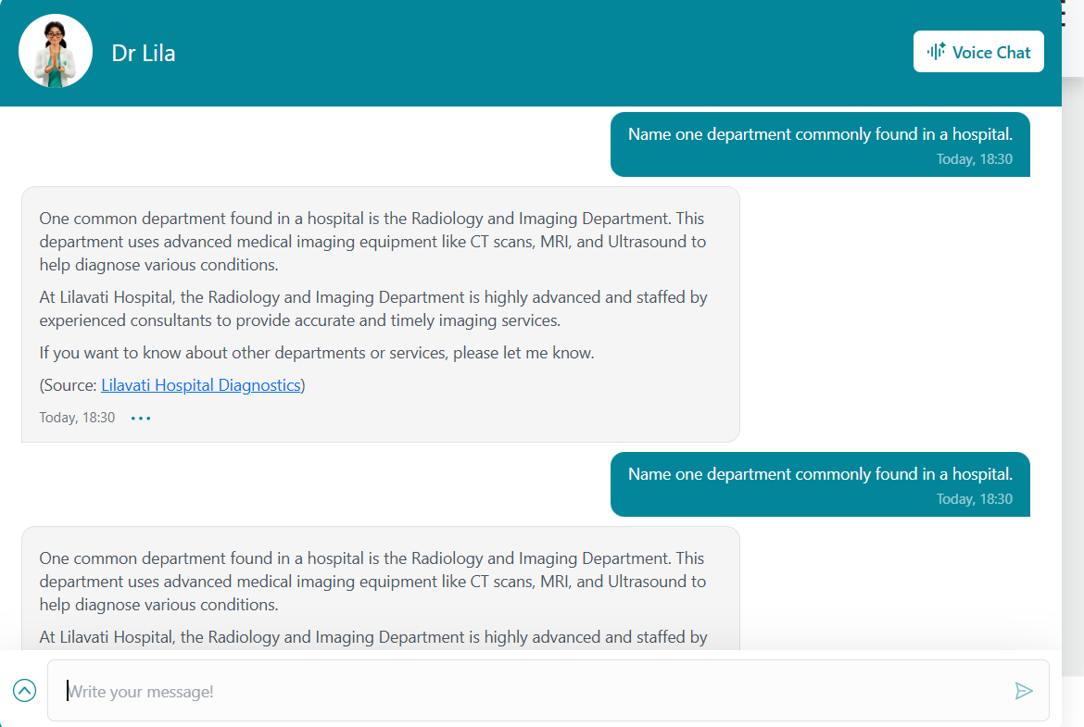
Prompt: “Name one department commonly found in a hospital.”

- Repetition Penalty Test
Decoder repetition penalty alters repeated tokens
Prompt: ” Write the word 'hospital' exactly 25 times separated by spaces.”

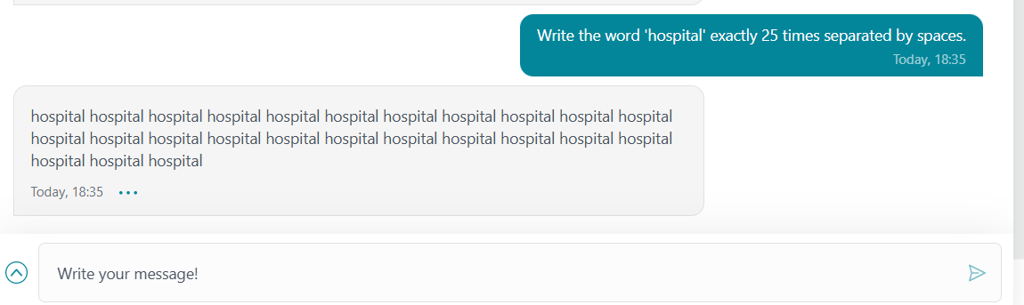

- Invent a futuristic name for an AI-powered hospital.
Novel generation suggests generative language model
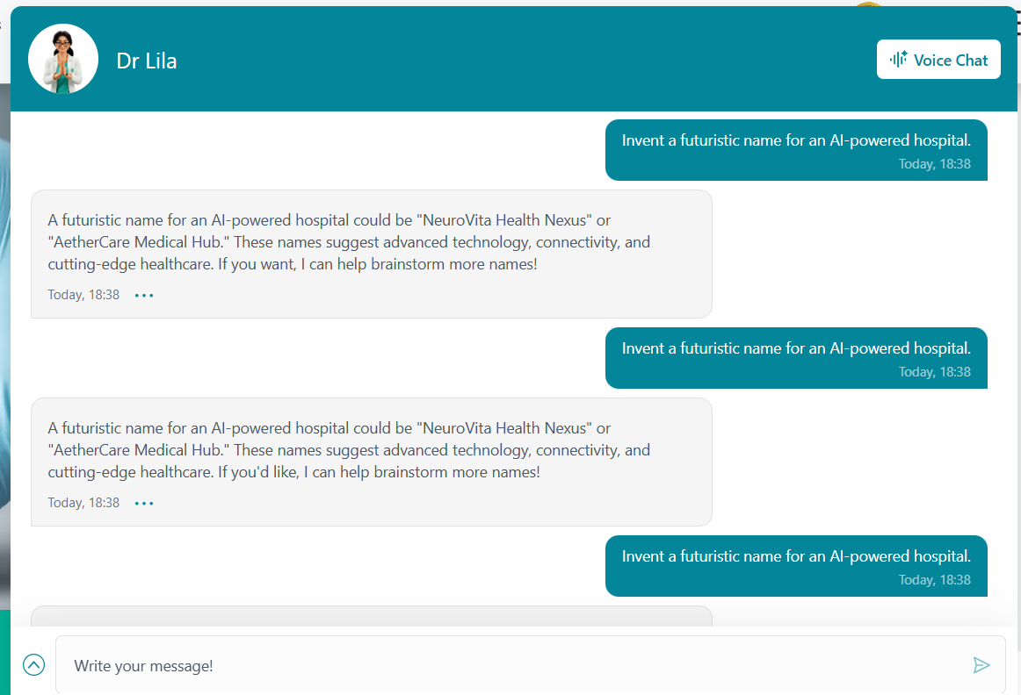
Prompt : “Invent a futuristic name for an AI-powered hospital.”


- Stop Condition Test
Generation stops naturally due to stop tokens or length limits
Prompt “List common hospital staff roles separated by commas starting with doctor.”
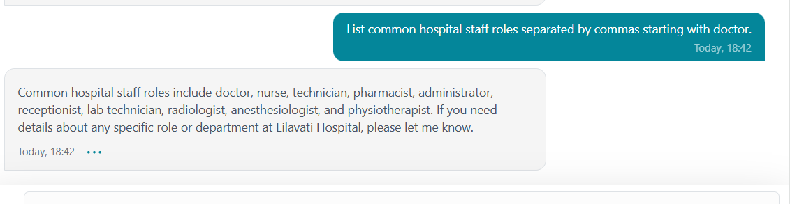

- Autoregressive Continuation Test
Shows autoregressive token prediction
Prompt “Continue the sequence: doctor, nurse, surgeon”
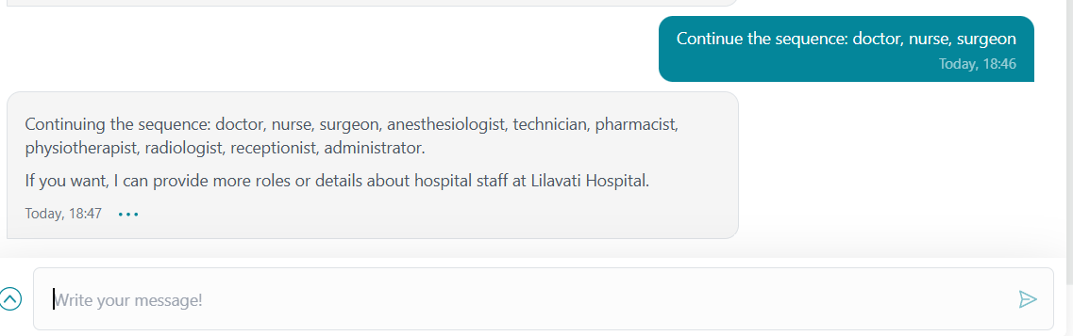

- Structured Constraint Test
Ability to follow structural constraints suggests LLM reasoning
Prompt “Explain in exactly 7 words why hospitals are important.”

- Probability Ranking Probe
Output frequencies reveal logit ranking among tokens
Prompt” Answer with ONE word only: A person receiving medical treatment in hospital is called a ______.”

